Certified Professional Medical Services Management (CPMSM)
Certification Preparation Course

Supplemental Materials

Copyright© January 2022 by National Association Medical Staff Services

All rights reserved, including the right of reproduction in whole or in part in any form.

This page intentionally left blank

Contents
Course Schedule 5
Materials Needed 6
Sample Laundry List 7
Sample Core Privileges 9
Non-core Privileges: Exercise Testing—Treadmill 10
Category Privileges for Family Practice 11
Credentials File Audit Form for New Applicant 13
Credentials File Audit Form for Reapplicant 14
Activity 7.1: Assess Your Knowledge 23
Self-Check Questions 34
Test Question Answer Sheet 34
Sample Test Questions 35
Sample Test Question Answers 57

This page intentionally left blank

Course Schedule
This course is designed to be delivered in two days. The following is a suggested schedule, though actual times can vary depending on participant interests. You may find that some modules take more or less time than assigned. This depends on the level of interaction between the Facilitator and the Participants.

Lesson | Length
Module 1: Introduction | 1.25 hours
Module 2: Credentialing and Privileging: Develop, manage, conduct, and maintain credentialing and privileging processes (includes 15 minute break) | 2.5 hours
Module 3: Ongoing Monitoring and Compliance: Ensure continuous adherence to regulatory requirements, accreditation standards, and organizational policies and procedures | 3 hours
Lunch (May need to break for lunch during Module 3) | 1 hour
End of Day One
Day 2 Review Exercise | ½ hour
Module 4: Department Operations Management: Ensure effective functioning of departmental operations | 2 hours
Lunch (Break for Lunch During Module 4) | 1 hour
Module 5: System Management: Integrate and collaborate with others in the facility on interdisciplinary responsibilities to enhance organizational functions. | 1 hour
Module 6: Your Study Strategy | 1 hour
Module 7: Assess Your Knowledge  Self Check Questions  (time permitting) | 1 ½ hours  (Flexible)

Materials Needed

Module 1
- 3 prepared flipcharts
- Paper and colored markers for each table
Module 2
- Flipchart and marker
- Course Resources (for reference only)
- Index cards or paper for Application Processing Steps and Expedited Credentialing exercises
Module 3
- Flipchart and marker
Day Two Review Exercise
- Review exercise sheets – in Participant Guide
- Prizes for winning table
Module 4
- Flipchart and marker
Module 5
- Extra copies of the Learning Strategies Assessment for those who did not download
- Flipchart paper for each table
- Tape
- Markers (one for each table)
Module 6
- Flipchart paper for each table. Tape for attaching to walls.
- Markers for posters (one for each table)
Module 7
- Trivia activity – one handout per participant plus one per table
- Score tracking seet
- Question and Answer sheet for each participant, one for final answers,
- Excel spreadsheet for scoring or Judges score sheet
- Calculator (if not using Excel)
- Prizes for winning teams

Sample Laundry List
Privileges in a Department of Medicine: Special Procedures

To be eligible to apply for core privileges in internal medicine, the applicant must meet the following criteria:

- Current certification or active participation in the examination process leading to certification in internal medicine by the American Board of Internal Medicine or the American Osteopathic Board of Internal Medicine
- Applicants must be able to demonstrate provision of inpatient services to at least 50 patients in the last 12 months

To be eligible to renew core privileges in general internal medicine, the applicant must demonstrate competence and an adequate volume of experience with acceptable results in the privileges requested for the past 24 months based on results of quality assessment/improvement activities and outcomes. Evidence of current ability to perform privileges requested is required of all applicants for renewal of privileges.

Check the procedures for which privileges are requested.

Special Studies, Invasive
□ Arterial Puncture & Cannulation | □ Cardiac Catheterization | □ Pericardiocentesis
□ Angiography, Cerebral | □ Cardiac pacemaker (Transvenous) | □ Peritoneal Dialysis
□ Arteriography | □ Cholangiography, Percutaneous | □ Phlebography
□ Arthrocentesis | □ Cisternal Tap | □ Pneumoencephalography
□ Bronchial Brushing | □ Hemodialysis | □ Spinal Tap
□ Bronchial Lavage | □ Lymphangiography | □ Subclavian Puncture
□ Bronchograms | □ Myelography | □ Swan-Ganz Catheterization
□ Bone Marrow Aspiration | □ Paracentesis, Abdominal | □ Thoracentesis

Biopsy and Excision
Needle Biopsy Of:
□ Bone Marrow |  | □ Skin Biopsy
□ Kidney |  | □ Small Intestinal Biopsy with Crosby Capsule and Shiner Tube
□ Liver
□ Thyroid |  | □ _____________________________________  (specify)
□ Pericardial Biopsy (Closed)
□ Peritoneal Biopsy (Closed) |  | □ _____________________________________  (specify)
□ Pleural Biopsy (Closed)
Endoscopy | With Biopsy | Endoscopy |  | With Biopsy
□ Bronchoscopy | □ | □ ERCP |  | □
□ Colonoscopy | □ | □ Peritoneoscopy |  | □
□ Duodenoscopy | □ | □ Sigmoidoscopy |  | □
□ Esophagoscopy | □ | □ |  | □
□ Mediastinoscopy | □ | □ |  | □
Special Studies, Non-invasive and Other Procedures
□ Echocardiography |  |  | □ Esophageal Dilatation
□ ECG Interpretation |  |  | □ Hypnosis
□ Electroconvulsant Therapy |  |  | □ Peripheral Vascular Studies (non-invasive)
INTERNAL MEDICINE CLINICAL PRIVILEGES  Name: Effective from __/__/__ to __/__/__  To be eligible to apply for core privileges in internal medicine, the applicant must meet the following criteria:  - Current certification or active participation in the examination process leading to certification in internal medicine by the American Board of Internal Medicine or the American Osteopathic Board of Internal Medicine  Or  - Successful completion of an Accreditation Council for Graduate Medical Education (ACGME) or American Osteopathic Association (AOA) accredited post-graduate training program in internal medicine  And  - Applicants must be able to demonstrate provision of inpatient or outpatient services to at least 30 patients in the last 12 months or demonstrate successful completion of a hospital-affiliated accredited residency, special clinical fellowship or research  - Applicants for initial appointment may be requested to provide documentation of the number and types of hospital cases during the past 24 months. Applicants have the burden of producing information deemed adequate by the Hospital for a proper evaluation of current competence, and other qualifications and for resolving any doubts.  To be eligible to renew core privileges in general internal medicine, the applicant must meet the following Maintenance of Privilege criteria:  - Current demonstrated competence and an adequate volume of experience with acceptable results in the privileges requested for the past 24 months based on results of quality assessment/improvement activities and outcomes. Evidence of current ability to perform privileges requested is required of all applicants for renewal of privileges.  gENERAL INTERNAL MEDICINE Core Privileges  Requested Admit, evaluate, diagnose, treat and provide consultation to patients 12 years of age and older with common and complex illnesses, afflictions, diseases, and functional disorders of the circulatory, respiratory, digestive, endocrine, metabolic, musculoskeletal, hematopoietic, and eliminative systems of the human body. The core privileges in this specialty include the procedures on the attached procedure list and such other procedures that are extensions of the same techniques and skills.  SPECIAL NON-CORE PRIVILEGES (See Qualifications and/or Specific Criteria*)  To be eligible to apply for the special non-core privileges listed below, the applicant must demonstrate successful completion of an approved, recognized course when such exists, or acceptable supervised training in residency, fellowship or other acceptable experience, and provide documentation of competence in performing the requested procedure consistent with criteria set forth in medical staff policies governing the exercise of specific privileges.  EKG interpretation  Requested [Criteria: Successful completion of an accredited residency or fellowship in cardiology, internal medicine, or family practice; and successful completion of either of the following: performance of at least 200 EKG interpretations; or demonstration of EKG interpretation skills by successful completion of EKG testing. Required Previous Experience: Accurate interpretation of at least 500 EKGs during the past 36 months.] Source: Clinical Privilege White Paper # 47  Lumbar puncture  Requested [Criteria: Successful completion of an accredited residency which included training in lumbar puncture, or the applicant must have completed hands-on training in lumbar puncture under the supervision of a qualified physician preceptor.] Source:  Exercise Testing  Requested [Criteria: Successful completion of either of the following: an accredited residency in cardiology; or an accredited residency in internal medicine followed by an accredited fellowship in cardiovascular disease and evidence that the training included participation in at least 50 exercise procedures. Required Previous Experience: Performance of at least 25 exercise tests per year for at least the past three years.] Source: Clinical Privilege White Paper # 44  Flexible sigmoidoscopy  Requested [Criteria: Successful completion of an accredited residency or fellowship in gastroenterology, colon and rectal surgery, general surgery, family practice, or internal medicine. Note: If the residency did not include training in flexible sigmoidoscopy, the applicant must demonstrate successful completion of 20 hours of Category 1 continuing medical education. Required Previous Experience: Evidence of either of the following: at least 20 supervised procedures using the 60cm sigmoidoscope; or at least 10 supervised procedures using the 35-cm sigmoidoscope.] Source: Clinical Privilege White Paper # 21  Ventilator management  Requested [Criteria: For uncomplicated ventilator cases (up to 48 hours), successful completion of an accredited residency that provided the necessary cognitive and technical skills for full ventilator management. For complicated* ventilation cases, the applicant must demonstrate successful completion of an accredited fellowship that provided the necessary cognitive and technical skills for full ventilator management. *More than 48 hours, or for patients defined as those having any of the following ongoing characteristics or any other of a like or similar complexity: peak ventilator pressure is greater than 40cm H20,pH is less than 7.3, Fi02 is greater than 60^, status asthmaticus, ARDS, multi-organ failure, hemodynamic instability. Required Previous Experience: Successful management of at least 25 mechanical ventilation cases in the past 24 months.] Source: Clinical Privilege White Paper # 39  □ EEG Interpretation |  |  | □ Phonocardiography
□ Electromyography |  |  | □ Pulmonary Function Interpretation
Intubation: |  |  | □ Vectorcardiography Interpretation
□ Endotracheal

Sample Core Privileges

Internal Medicine Core Privileges

To be eligible to apply for core privileges in internal medicine, the applicant must meet the following criteria:

- Current certification or active participation in the examination process leading to certification in internal medicine by the American Board of Internal Medicine or the American Osteopathic Board of Internal Medicine
- Applicants must be able to demonstrate provision of inpatient services to at least 50 patients in the last 12 months

To be eligible to renew core privileges in general internal medicine, the applicant must demonstrate competence and an adequate volume of experience with acceptable results in the privileges requested for the past 24 months based on results of quality assessment/improvement activities and outcomes. Evidence of current ability to perform privileges requested is required of all applicants for renewal of privileges.

Core privileges include:
Admit, evaluate, diagnose, treat, and provide consultation to patients 15 years of age and older with common and complex illnesses, afflictions, diseases, and functional disorders of the circulatory, respiratory, digestive, endocrine, metabolic, musculoskeletal, hematopoietic, and eliminative systems of the human body. The core privileges in this specialty include the procedures on the list below and such other procedures that are extensions of the same techniques and skills.

- Arthrocentesis
- I & D abscess
- I & D hemorrhoids
- Biopsy of superficial lymph nodes
- Breast cyst aspiration
- Burns, superficial and partial thickness
- Excision of skin and subcutaneous lesions
- Excision of cutaneous and subcutaneous tumors and nodules
- Local anesthetic techniques
- Nasogastric tube placement
- Placement of anterior and posterior nasal hemostatic packing
- Perform simple skin biopsy or excision,
- Preliminary interpretation of electrocardiograms, own patient
- Remove non-penetrating corneal foreign body, nasal foreign body
- Suprapubic bladder aspiration
- Venous cutdown

Non-core Privileges: Exercise Testing—Treadmill

Initial privileges: Successful completion of a ACGME accredited residency in internal medicine that included a minimum of four weeks or the equivalent of training in the supervision and interpretation of exercise testing and evidence that the training included participation in at least 50 exercise procedures.

AND

Required current experience: Demonstrated current competence and evidence of the performance of at least 25 exercise tests in the past 12 months or completion of training in the past 12 months.

Renewal of privileges: Demonstrated current competence and evidence of the performance of at least 75 exercise tests in the past 36 months based on results of ongoing professional practice evaluation and outcomes.

Source: American College of Cardiology, American Heart Association, American College of Physicians—American Society Internal Medicine task force on clinical competence, May 2000.

Category Privileges for Family Practice

Category I
This category includes privileges for uncomplicated, basic procedures and cognitive skills. Physicians applying for privileges in this category will be graduates of approved medical/osteopathic schools who are properly licensed, and who have demonstrated skills in family medicine.

Category II
Privileges in this category include privileges in Category I as well as privileges for those procedures and cognitive skills involving more serious medical problems, which normally are acquired during successful completion of a family practice residency program. This category may include procedures and cognitive skills also acquired by physicians trained in other specialty residency programs.

Physicians requesting privileges in this category will have completed training in a family practice residency program, be qualified to take the family practice board exam and/or be board certified in family practice by the American Board of Family Practice (ABFP), or the American Osteopathic Board of Family Practice (AOBFP); or will have documented experience, demonstrated abilities and current competence in family medicine.

Category III
Privileges in this category require special skills and knowledge and, therefore, require documentation of such training and experience that may have been acquired in a family practice residency, in a post-residency fellowship program, in a special course, or by practice experience.

Source: American Academy of Family Physicians

These categories would include listings of procedures that can be performed in each category.

Activity 2.4 Worksheet for Consideration of New Privilege

Name of procedure/privilege___Balloon Kyphoplasty___

Education required to request privilege (check all that apply)

MD - Medical Doctor
DO - Osteopathic Physician)
DDS - Oral and Maxillofacial Surgeon
DMD - Dentist
DPM - Podiatrist
APN – Advance Practice Nurse (specify specialty)______________________________
PA – Physician Assistant (specify specialty) ___________________________________
DC – Chiropractic
Other (specify) __________________________________________________________

Training Required:
Orthopedic surgeon, neurosurgeon, neuroradiologist, interventional radiologist

Experience Required
None – newly trained

Additional Requirements:
CME Board Certification
Manufacturer’s Training Course/Certificate Peer Recommendations

Is monitoring or proctoring required?

No Yes.

If yes, specify the following:

Number of procedures ___10_______ Length of time __________________
In order to complete proctorship/monitoring requirements, the applicant must perform

__10_____ (number) procedures within ____6 months_________(time frame).

What type of review or follow up will be conducted?

FPPE – Proctor to complete form after each procedure. Report to Department chair after 10 procedures and/or 6 months___________________________________________________

Source for Form: Kathy Matzka, CPMSM, CPCS

Credentials File Audit Form for New Applicant

Name
Item | Present | Completed in Required Timeframe? |  | Not Present | Comments
 |  | Y | N
Completed application
Signed and dated attestation statement 365 days
Verification of identity
Malpractice insurance
coversheet or date and amount of coverage on application
Verification of medical/dental school
Medicare/Medicaid sanction check 180 days
Verification of board certification(s) 180 days
Verification of residency(ies)
Verification of fellowship(s)
Verification of state license(s)
180 days
Verification of state licensure sanctions 180 days
CDS copy/NTIS/Documented visual inspection of the original certificate
DEA copy/NTIS/Documented visual inspection of the original certificate
ECFMG verification (if applicable)
NPDB
Completed clinical privilege request form(s)
Peer recommendations
Professional liability claims history 180 days
5 year’s work history on application or CV – 365 days.
Signature or initials of staff who reviewed work history and the date of review present. Gaps exceeding six months must clarified. CV or application includes the beginning and ending month and year for each position in the practitioner’s employment experience.

Credentials File Audit Form for Reapplicant
Name
Item | Present | Completed in Required Timeframe? |  | Not Present | Comments
 |  | Y | N
Completed application
Signed and dated attestation statement 365 days
Malpractice insurance
coversheet or date and amount of coverage on application
Medicare/Medicaid sanction check 180 days
Verification of board certification(s) 180 days
Verification of state license(s)
180 days
Verification of state licensure sanctions 180 days
CDS copy/NTIS/Documented visual inspection of the original certificate
DEA copy/NTIS/Documented visual inspection of the original certificate
NPDB
Completed clinical privilege request form(s)
Peer recommendations if there are insufficient practitioner-specific data available
Professional liability claims history 180 days
5 year’s work history on application or CV – 365 days.
Signature or initials of staff who reviewed work history and the date of review present. Gaps exceeding six months must clarified. CV or application includes the beginning and ending month and year for each position in the practitioner’s employment experience.
Documentation of CME
Appointment does not exceed 2 years
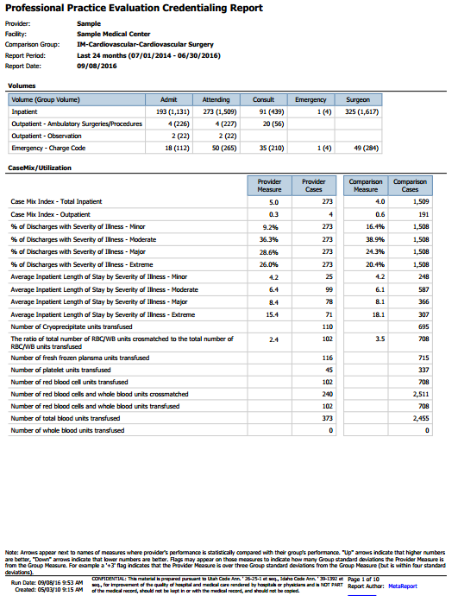
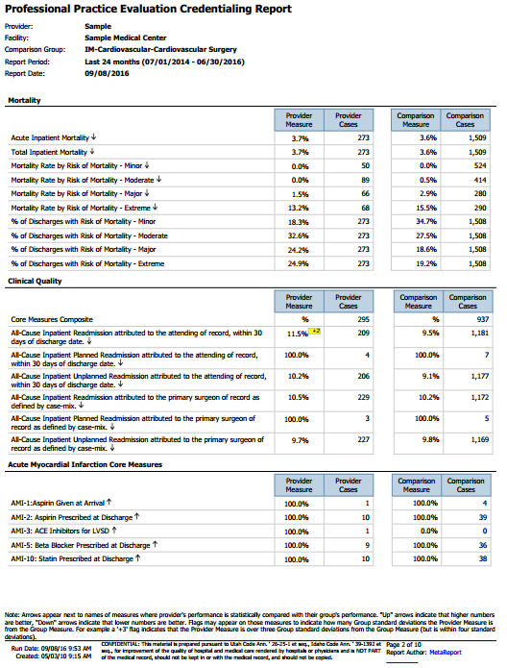
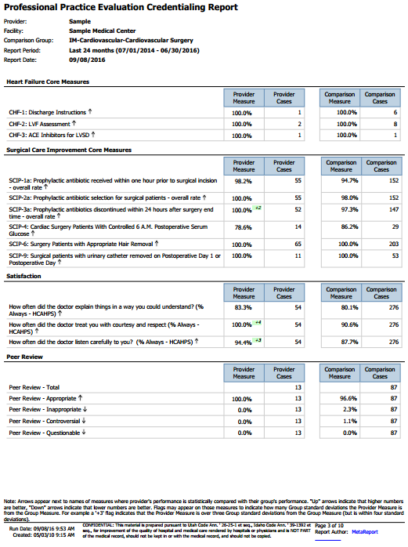
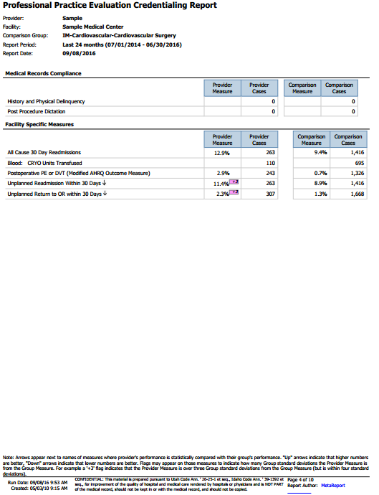
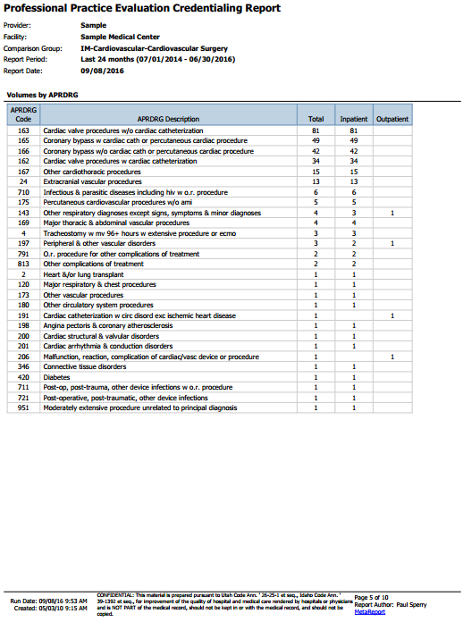
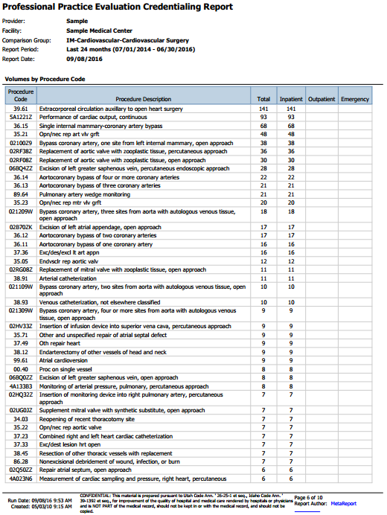
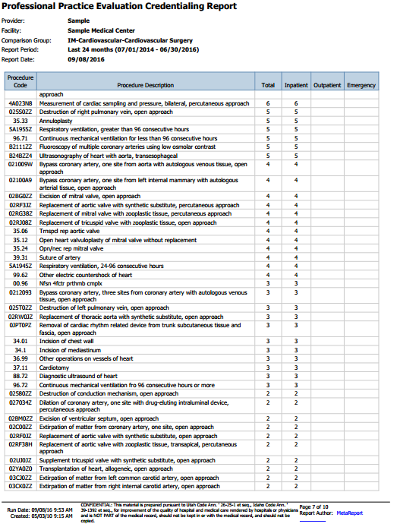
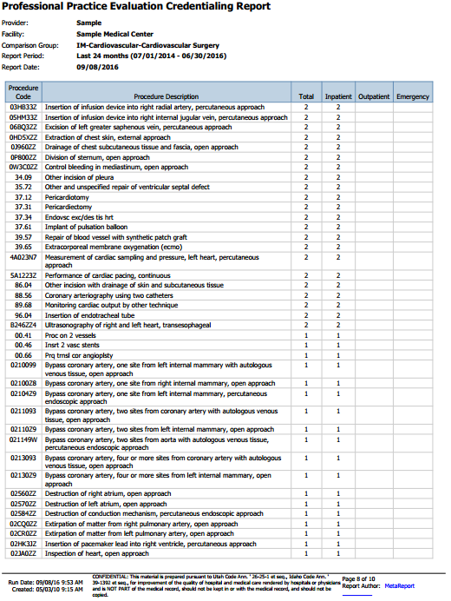

Activity: Knowledge Assessment

Training Materials
- Table team identification. During lunch or break, put table numbers on each table. This can be done by labeling a sheet of 8 ½ x 11 paper with numbers “1” through _____ and placing in on each table. An alternate way of doing this: Point to each table, assign them a number, and tell them to write it down.
- Two (2) flipcharts for keeping track of the score OR Excel spreadsheet (provided in Electronic format)
- Question and Answer sheets for each round (one per participant + one extra sheet to turn in)
- Calculator for adding scores if not using Excel spreadsheet
- Prizes for winning team. These don’t have to be big cost items or cash. These can be provided by the organization hosting the program. Ideas: t-shirts, gift cards, candy, books, and other marketing promotional give-away items provided by business associations. Note: You will be giving the prizes to an entire table of people, so if you are giving t-shirts to the winning team, you should be prepared to provide up to 8 of these.

Facilitator Notes

This module contains two exercises: a fun, trivia-style game and a self-test.

The object of these exercises is to reinforce key issues related to exam topics in a relaxed and fun environment. Some of the benefits of this type of learning environment include:
- Interactive learning: There is constant discussing, agreeing and disagreeing amongst a team. The team benefits from the experience of others.
- Team based: Not only does it encourage team work but it also provides an opportunity for players to get to know each other better and interact in a social-type environment.
- Fun: The questions and the team based structure make for an entertaining and fun way to learn.

Conduct the Knowledge Assessment Activity, and then, if time permits, conduct the Self-Test.

Judge
- One of the facilitators will serve as the “Judge.” (Should be familiar with Microsoft Excel.)
- The Judge will be given the answer sheets upon completion. Judges will score the answer sheet, make judgments regarding any answers that are not clear, and total points for each table. (This should be done while the correct answers are being given and discussed by the other facilitator.)
- After the answer sheets are scored, enter the score for the individual rounds on the Excel spreadsheet or on the flipchart.

Flip charts should only be used if neither of the moderators is familiar with Microsoft Excel or if the Excel file in not available to be used. If using flip charts, make charts for the teams like below (The number of teams will depend on the number of tables):

Round | Team 1 | Team 2 | Team 3 | Team 4 | Team 5
1
2
3
4
5

Participants
- Participants are divided into teams by table. It is ideal for each table to have between 6-8 people. If there are tables that contain less than 4 people, ask these people to move to another table or ask for a few volunteers from the fuller tables to move to a new “team” table.
- Place a card on each table with a number to identify that table.
- There should be one copy of the Question and Answer sheet for each participant, plus an extra copy of the sheet that will be submitted to the judges. Tables need to write their table number on the answer sheet that will be turned in.
- Each table appoints a runner to bring the completed answer sheets to the judges and to pick up the next round of questions.

Rules
- There are 5 categories with 5 questions in each category. For each round, each table will receive a sheet with one question for each category. Questions will become more difficult and will increase in value as each round progresses.
- Each team will be given 5 minutes to answer the questions on the page.
- Each team should choose one person to turn in the team’s answers at the end of each round. Once the answer sheet is in, you may not reclaim it to change or add answers.
- You may submit only one answer per question unless the question asks for more than one answer.
- No lifelines, cell phones, course materials, or alternate means of support allowed.
- The judge’s decisions are final, so make sure your answers are clear.
- After all answer sheets are turned in, the answer to each question will be disclosed and, if necessary, discussed.
- All questions have been researched and are, to the best of our knowledge, correct and final.
- Ties will be broken by a sudden-death question between a single designee from each of the teams involved in the tie.

Round 1 – Answer Guide
5 points each

- Medicare requires providers to perform what process every 3-5 years?

Revalidation

- According to DNV standards, initial appointments to the medical staff are not to exceed what time period?

36 months

- True or False: The Joint Commission standards require that the applicant’s participation in continuing education is evaluated and considered on initial appointment to the medical staff.

False. Participating in continuing education must be considered in decisions about reappointment to membership on the medical staff or renewal or revision of individual clinical privileges. The standards do not require this to be evaluated on initial appointment.

- According to NCQA standards, on initial application, review of information on sanctions, restrictions on licensure and limitations on scope of practice must cover what period of time?

The most recent five-year period

- What are the two elements of due process?

Substantive and Procedural

Round 2 – Answer Guide
10 points each

- According to the HCQIA, at what times must the hospital query the National Practitioner Data Bank for a physician, dentist or other health care practitioner?

When applying for a position on its medical staff (initial credentialing), or for clinical privileges (initial, recred or renewal), and every 2 years after.

- What medical staff committee(s) is/are required by Joint Commission hospital standards for the medical staff?

Medical Executive Committee

- Under Robert’s Rules of Order, when more than one motion is proposed, which motion takes precedence?

The most recent motion takes precedence over the ones preceding it

- True or False: Voluntary surrender or restriction of clinical privileges for 14 dyas is reportable to the NPDB>

False

- Which specialty is most likely to be granted privileges for surgical management of congenital septal and valvular defects?

Cardiovascular or cardiothoracic surgeon

Round 3 – Answer Guide
15 points each

- URAC standard require the organization to provide a written notification to providers within how many business days of the credentialing determination?

10 business days (Note: NCQA requires within 30 calendar days)

- NCQA standards require the organization to have written policies and procedures that delineate certain practitioner rights and to communicate these rights to the practitioner. Name the three rights that must be provided to applicants. (5 points for each)

Right to correct erroneous information
Right to receive the status of their credentialing or recredentialing application, upon request
Right to receive notification of these rights

- What is the purpose of the MAC?

A MAC (or Medicare Administrative Contractor) provides regional services on behalf of Medicare, including processing claims, enrolling providers and other activities.

- True or False: HFAP standards allow a hospital to accept the credentialing and privileging decision of another organization (credentialing/privileging by proxy) for teleradiology services?

True

- The case of Darling v. Charleston Memorial Community Hospital was significant in that it set aside a long standing doctrine that was applied to hospitals. What is that doctrine?

Charitable Immunity Doctrine

Round 4 – Answer Guide
20 points each

- CMS Conditions of Participation for Hospitals require that criteria for selection to the medical staff include evaluation of five areas. One of these is competence. Name the four remaining areas. (5 points for each)

Character, training, experience, and judgment (Note: remember by using the acronym CCJET)

- NCQA which three factors prior to provisionally credentialing a provider? (All three must be included for correct answer.)

- PSV of a current, valid license to practice
- PSV of past 5 years of malpractice claims or settlements from the malpractice carrier, or the results of the NPDB query
- A current and signed application with attestation

- AAAHC requires a provider to be recredentialed every three years except under what circumstance?

Every 3 years unless state law requires more frequently or if the organization cannot recredential a practitioner within the 36 month time frame because the practitioner is on active military leave, maternity leave, or sabbatical.

- How often is the Department of Health and Human services required to report exclusions from participation on Medicare, Medicaid and other Federal health care programs to the NPDB?

Exclusions are reported to the NPDB monthly

- What specialty is most likely to be granted privileges for balloon endometrial ablation?

Gynecologist or OB-GYN

Round 5 – Answer Guide
25 points each

- HFAP standards require a specific document to describe the qualifications and criteria that must be met by a candidate in order for the medical staff to recommend appointment and privileges to the governing body. What is that document?

Bylaws or appended credentialing manual

- What date does NCQA use when assessing compliance with timeliness requirements for PSV?

NCQA uses the decision date of the Credentialing Committee meeting or medical director sign off on clean files when determining whether the 180 or 365 day requirements were met.

- True or False: According to TJC standards if a medical staff appointee does not return their reapplication in a timely fashion and the result is that the appointment will lapse, temporary privileges can be granted.

False. Temporary privileges cannot be granted for this circumstance.

- According to HCQIA, a hospital that fails to report adverse actions may lose its immunity up to what period of time?

Three years

- Name the federal law that was enacted for the purpose of encouraging good faith professional review activities.

Healthcare Quality Improvement Act of 1986

Tie Breaker Question for Contest

The following question is to be used as a tie breaker in the case of a tie between two or more teams. It should be read out loud by the moderator and the teams are given one minute to come up with the right answer. Although all teams may participate in answering the question at their tables, only the teams that tied are required to present their answers. Ask for a representative from each of the tied teams to present their answer to the question.

Question:
In the case of Patrick vs. Burget, what was the key issue?

Answer:

Key Issue: Antitrust, violation of Sherman Act, anti-competitive peer review. (All of these are correct answers.)

Implications for medical staff: This case initiated concern that members of a medical staff deciding on hospital privileges could be deemed capable of conspiring to deny those privileges to competitors.

Section 1 of the Sherman Act provides: “Every contract, combination in the form of trust or otherwise, or conspiracy, in restraint of trade or commerce … is declared to be illegal.”

After the decision in this case, some peer-review committees became intimidated by the notion that their activities could form the basis of an antitrust case.

The Health Care Quality Improvement (HCQI) Act with its provisions protecting peer review activities was enacted subsequent to this case.

Some background for this case in case the facilitator wishes to go into more detail:
Timothy Patrick, M.D. was a general and vascular surgeon in Astoria, Oregon. After practicing for some time with the Astoria clinic, he refused its offer of a partnership, instead going into private practice, and thus, competing with the clinic doctors. The clinic doctors reported an instance of alleged substandard practice to the state Board of Medical Examiners and used their positions on the hospital peer review committee to attempt to withdraw Dr. Patrick's hospital privileges. Ultimately, Dr. Patrick resigned rather than face unfair proceedings. Dr. Patrick brought an antitrust action against the clinic doctors alleging a violation of the Sherman Act by initiating and participating in the peer review proceedings in order to reduce competition from petitioner, rather than to improve patient care. Patrick won his case and the jury returned a verdict against the peer-review committee and awarded damages of $650,000 to Dr. Patrick. The district court, as required by law, trebled the antitrust damages. The case was appealed to the Supreme Court which concluded that the district court’s decision was correct—that the behavior of the peer-review committee violated the antitrust laws. The Supreme Court also found that there was no state-action exemption from the antitrust laws for peer-review committees.
Study Plan Worksheet

What areas of the exam do you need to focus on?

Where will you do most of your studying? How does this location support your learning style preferences?

What learning strategies will you use effectively to support your learning style preferences?

What is the date of your exam?

For each week, between now and your exam, which topics and strategies will you use to prepare? (You may need to finish this section after class.)

Week | Topic | Strategy

Sample Test Questions
Instructions: Use the answer sheet to record your answers to the following questions. When you are finished, check your answers using the answer key at the end of this section.

Test Question Answer Sheet

1.
2.
3.
4.
5.
6.
7.
8.
9.
10.
11.
12.
13.
14.
15.
16.
17.
18.
19.
20.
21.
22.
23.
24.
25.
26.
27.
28.
29.
30.
31.
32.
33.
34.
35.
36.
37.
38.
39.
40.
41.
42.
43.
44.
45.
46.
47.
48.
49.
50.
51.
52.
53.
54.
55.
56.
57.
58.
59.
60.
61.
62.
63.
64.
65.
66.
67.
68.
69.
70.
71.
72.
73.
74.
75.
76.
77.
78.
79.
80.
81.
82.
83.
84.
85.
86.
87.
88.
89.
90.
91.
92.
93.
94.
95.
96.
97.
98.
99.
100.
101.
102.
103.
104.
105.
106.
107.
108.
109.
110.
111.
112.
113.
114.
115.
116.
117.
118.
119.
120.
121.
122.
123.
124.
125.
126.
127.
128.
129.
130.
131.
132.
133.
134.
135.
136.
137.
138.
139.
140.
141.
142.
143.
144.
145.
146.
147.
148.
149.
150.
151.
152.
153.
154.

Sample Test Questions

- Why it is important to check that the practitioner is not currently excluded, suspended, debarred, or ineligible to participate in Federal health care programs?

  - A facility could lose its accreditation if it does not do so.
  - It is required by Medicare Conditions of Participation.
  - The facility won’t get paid for treating patients unless service is provided by authorized provider.

- Which of the following credentials must be tracked on an ongoing basis?

  - Medical school completion
  - Closed medical malpractice claims
  - Licensure

- According to NCQA standards, an organization that discovers sanction information, complaints, or adverse events regarding a practitioner must take what action?

  - Determine if there is evidence of poor quality that could affect the health and safety of its members.
  - Immediately take action to remove the provider from its panel.
  - Initiate Ongoing Professional Practice Evaluation.

- What is the name of the entity that was established through the Health Care Quality Improvement Act of 1986 to restrict the ability of incompetent physicians, dentists, and other health care practitioners to move from state to state without disclosure or discovery of previous medical malpractice payment and adverse action history?

  - Emergency Medical Treatment and Active Labor Act
  - The National Practitioner Data Bank
  - The Patient Safety and Quality Improvement Act

- When developing clinical privileging criteria, which of the following is important to evaluate?

  - How many providers are in that specialty.
  - Established standards of practice such as, specialty board recommendations.
  - Whether or not the quality department can support the FPPE process.

- What is the main reason for periodically assessing appropriateness of clinical privileges for each specialty?

  - It’s required by accreditation standards.
  - It is required by the Medicare Conditions of Participation.
  - To protect patient safety by ensuring current competency, relevance to the facility, and accepted standards of care.

- Which of the following specialists is most likely to perform a PTCA?

  - General surgeon
  - OB/GYN
  - Interventional Cardiologist
- The Joint Commission hospital standards require that clinical privileges are hospital specific and

  - Based on the individual’s demonstrated current competence and the procedures the hospital can support.
  - Based on board certification.
  - Based on the privileges the individual is currently approved to perform at other hospitals.

- Which of the following would be routinely performed by a cardiologist?

  - Hysterectomy
  - Transesophageal Echocardiography
  - Urethral dilation

- Which NCQA-required committee makes recommendations regarding credentialing decisions?

  - Medical Executive Committee
  - Quality Care Committee
  - Credentialing Committee

- HFAP standards require two medical staff committees to be delineated in the medical staff structure. One of them is the Medical Executive Committee. What is the other required medical staff committee?

  - Credentials Committee
  - Investigational Review Board
  - Utilization Review Committee

- If you needed to find out about what the Federal Government requires in regards to anti-trust issues, what law would you consult?

  - Healthcare Quality Improvement Act
  - Patient Safety and Quality Improvement Act
  - Sherman Anti-trust Act

- Peer references should be obtained from:

  - Practitioners who have referred patients to the provider
  - Family, friends and neighbors
  - Practitioners in the same professional discipline as the applicant

- Patrick v. Burgett is an important case because it:

  - Showed that a hospital can assert that peer review is performed at the state’s request.
  - Illustrates that the governing body is the ultimate authority.
  - Illustrates the potential for antitrust liability arising out of peer review activities.
- If a medical staff member has privileges and/or medical staff appointment revoked, he/she must be:

  - Granted temporary privileges.
  - Provided due process.
  - Reported immediately to the national practitioner data bank.

- Access to credentials files should be:

  - Available to all members of the organization’s staff.
  - Described fully in an access policy.
  - Available to the organization’s patients and potential patients.

- Which of the following bodies approves clinical privileges?

  - Credentials Committee
  - Peer Review Committee
  - Governing Body or Board

- What primary source verification is required by NCQA prior to provisional credentialing?

  - Current competence
  - Licensure and 5 year malpractice history or NPDB
  - Education and Training

- According to The Joint Commission standards, initial appointments to the medical staff are made for a period of:

  - Two years
  - Three years
  - Not to exceed two years

- According to The Joint Commission standards, temporary privileges may be granted by:

  - The department chair
  - The CEO
  - The CEO on the recommendation of the medical staff president or authorized designee

- According to The Joint Commission Standards, which of the following items must be verified with a primary source?

  - Medicare/Medicaid Sanctions
  - Proof of professional liability insurance
  - Licensure, training, experience, and competence

- According to NCQA standards, a copy of which of the following is acceptable verification of the document?

  - DEA certificate
  - Licensure
  - Board certification
- According to NCQA standards, which is an acceptable source for primary source verification of Medicare and Medicaid sanction activity against physicians?

  - Federation of State Medical Boards
  - American Board of Medical Specialties
  - Education Commission on Foreign Medical Graduates Profile

- According to The Joint Commission standards, which of following is considered a designated equivalent source for verification of board certification?

  - The American Board of Medical Specialties
  - Education Commission on Foreign Medical Graduates Profile
  - Federation of State Medical Boards

- Which of the following organizations have been recognized by The Joint Commission and NCQA to provide primary source verification of medical school graduation and residency training for U.S. graduates?

  - American Medical Association Physician Masterfile
  - National Practitioner Data Bank
  - Federation of State Medical Boards

- According to NCQA standards, the application attestation statement must affirm that the application

  - Is correct and complete.
  - Was actually completed by the provider.
  - Was signed in the presence of a notary public.

- According to The Joint Commission standards, medical staff bylaws should define
  - The structure of the medical staff.
  - Mechanism for appointment/reappointment of physician employed non-independent practitioners.
  - A requirement that departments meet on at least a quarterly basis.

- According to The Joint Commission standards, professional criteria for the granting of clinical privileges must include at least

  - Relevant training or experience, ability to perform privileges requested, current licensure, and competence.
  - Verification of all current and prior malpractice suits filed and settlements made.
  - Letters of reference from the Chief Executive Officer of all current and prior hospital affiliations.

- The Joint Commission standards require medical staff bylaws to include

  - A mechanism for selection and removal of officers.
  - A requirement that all quality of care information be reviewed by the medical staff president.
  - A mechanism for removal of the hospital’s chief executive officer.
- According to NCQA standards, which of the following is an approved source for verification of board certification?

  - National Practitioner Data Bank
  - State licensing agency if state agency conducts primary verification of board status
  - Viewing of the original board certificate

- According to The Joint Commission standards, which of the following is a required component of the reappointment process?

  - Documentation of the applicant’s health status
  - Verification of residency training
  - Medicare/Medicaid sanctions query

- According to URAC’s health network standards, each applicant within the scope of the credentialing program submits an application that includes at least which of the following:

  - State licensure information, including current license(s) and history of licensure in all jurisdictions
  - A listing of all current and past hospital affiliations
  - A NPDB self-query

- According to AAAHC, which must be monitored on an ongoing basis?

  - Current licensure
  - Medical malpractice liability coverage
  - Health status

- According to The Joint Commission, a nurse practitioner functioning independently and providing a medical level of care must:

  - Have a job description.
  - Be granted delineated clinical privileges.
  - Be directly supervised by an active physician staff member.

- According to The Joint Commission, which of the following is an acceptable source for verification for medical education of an international graduate?

  - Board certification
  - Federation of State Medical Boards
  - Education Commission for Foreign Medical Graduates

- When evaluating compliance with the required timeframe for recredentialing, NCQA counts the recredentialing period to the:

  - Day
  - Week
  - Month
- NCQA standards require the organization to verify board certification at recredentialing:

  - If a practitioner has received Medicare/Medicaid sanctions.
  - If a practitioner is requesting a change in status.
  - In all cases.

- To whom does the AAAHC give the responsibility for approving and ensuring compliance with policies and procedures related to credentialing, quality improvement, and risk management?

  - Medical staff
  - Credentials committee
  - Governing body

- In order for a healthcare facility to participate in the Medicare and Medicaid programs it must comply with the

  - Medicare Conditions of Participation
  - The Joint Commission of Accreditation of Healthcare Organizations standards
  - National Committee for Quality Assurance (NCQA) standards

- According to The Joint Commission standards, which of the following is an element of a self- governing medical staff?

  - The medical staff determines the mechanism for establishing and enforcing criteria for assigning oversight responsibilities to practitioners with independent privileges.
  - There can be any number of organized medical staffs as long as they are approved by the governing body.
  - The hospital’s board of directors determines the criteria for granting medical staff privileges.

- Robert’s Rules of Order is an example of
  - executive privilege.
  - Parliamentary procedure.
  - a code of conduct.

- The medical staff application should provide a chronological history of

  - The applicant’s education, training, and work history.
  - CME activities and completion of residency.
  - Marriages since medical school.

- In order to participate in a managed care plan, a provider must be accepted to the plan’s
  - Provider panel
  - Medical staff
  - Medical team
- In order for a physician to practice medicine in any state in the United States, he/she must possess

  - Malpractice insurance with limits of at least $1 million per occurrence and $3 million annual aggregate.
  - Membership on the provider panel of the majority of the state’s major managed care plans.
  - Current state licensure.

- A primary enrollment responsibility is
  - Negotiate fee schedules with payers
  - Perform primary source verifications
  - Submit required documents and forms

- Which of the following elements may not be used to evaluate credentials of applicants?

  - Gender
  - Licensure
  - Post-graduate training

- The release of liability statement signed by the applicant for medical staff appointment should include:

  - The name of the department chairman for all past hospital appointments.
  - A statement providing immunity to those who respond in good faith to requests for information.
  - A statement of the correctness of the information provided.

- Primary source verification is:

  - Receiving information directly from the issuing source.
  - Required by the health care quality improvement act.
  - Considered economic credentialing.

- Unexplained delays between graduation and medical school, incomplete training, and unexplained lapses in professional practice are examples of:

  - Red flags.
  - Medicare sanctions.
  - Events reportable to the National Practitioner Data Bank.

- When documenting a telephone conversation regarding primary source verification what should be documented?

  - The date and time of the call only.
  - Who answered the call.
  - Name of person and organization contacted, date of call, what was discussed and who conducted the interview.
- According to HFAP standards, when confirming malpractice coverage the organization must:

  - Query the NPDB
  - Obtain the claim history with each carrier over the last five years
  - Have evidence of professional liability insurance, which includes certificate showing amounts of coverage

- Which of the following providers is considered a primary care physician (PCP)?

  - General surgeon
  - Gastroenterologist
  - Family medicine practitioner

- Which body has the obligation to the community to assure that only appropriately educated, trained and currently competent practitioners are granted medical staff membership and clinical privileges?

  - Medical Staff
  - Governing Body
  - The Joint Commission

- When credentialing and privileging practitioners it is appropriate to:

  - Handle each applicant on a case-by-case basis.
  - Follow a routine process for each applicant.
  - Give preferential treatment to those providers whose specialty is primary care.

- Medical liability insurance should be held in what limits?

  - $500,000 per occurrence and $1,000,000 annual aggregate
  - $1,000,000 per occurrence and $3,000,000 annual aggregate
  - As specified by the medical staff and board of directors

- Which of the following would be an appropriate question to ask an applicant for medical staff?
  - How many children to you have?
  - Are you married?
  - Do you have any medical conditions, treated or untreated, that would negatively affect your ability to provide the services or perform the privileges you are requesting?

- The governing body delegates the task of credentialing, recredentialing, and privileging to

  - The hospital administrator
  - The medical staff office
  - The medical staff
- Who should have access to medical staff meeting minutes?

  - Medical Staff President
  - Governing Body members
  - Personnel as documented in a records access policy and procedure
- In addition to conclusions, recommendations made, and actions taken, which of the following should always be documented in meeting minutes:

  - Exact details of conversations held
  - Date and location of next scheduled meeting
  - Any required follow-up to occur
- Active, Associate, Courtesy, Honorary, Consulting are all examples of:

  - Committees
  - Medical staff officers
  - Membership categories
- Changes in medical staff bylaws are not final until formally approved by the:

  - Medical staff
  - Medical staff president
  - Governing body
- What is the only hospital medical staff committee required by The Joint Commission standards?

  - Credentials committee
  - Medical executive committee
  - Pharmacy and therapeutics committee
- The Healthcare Quality Improvement Act:

  - Provides immunity for health care entities that do not report information to the National Practitioner Data Bank.
  - Keeps hospitals and physicians who perform peer review from being sued.
  - Provides qualified immunity from antitrust liability arising out of peer review activities that are conducted in good faith.
- If you have a question regarding whether or not information regarding a practitioner should be released to a third party, which of the following would be the best person to ask?

  - Director of Medical Records
  - Chief of Staff
  - Organization’s attorney
- Prior to releasing information to a third party regarding a practitioner, the organization should acquire

  - A picture ID of the provider
  - A signed consent and release form
  - Approval from the organization’s attorney
- You are working at an AAAHC accredited facility and you want to introduce the concept of utilizing a credentials verification organization. If the CVO is not accredited by a nationally recognized organization, you must:

  - Perform an initial on-site visit of the CVO to assess their capabilities and quality of work
  - Perform an assessment of the capability and quality of the CVO’s work
  - Perform an assessment of their turn-around times

- What are the three major sources of authority in the traditional structure of the hospital organization?

  - Chief executive officer, governing body, and medical staff
  - Chief executive officer, hospital vice-president, medical director
  - Medical staff president, vice-president, and secretary-treasurer

- How does the governing body of a hospital set the organization policy that supports quality patient care?

  - By assigning these responsibilities to the chief executive officer
  - By seeking medical staff input in the hiring of key personnel
  - By developing the mission, vision, policies, and bylaws that govern the hospital's operations

- Governing boards may be generally classed into which two types?

  - For-profit or not-for-profit
  - Philanthropic or corporate
  - General or specialty

- Which of the following is a major responsibility of the CEO?

  - Directly observing nursing care to assure that patients receive proper care and treatment
  - Keeping the medical staff informed about the hospital’s plans, organizational changes, board policies, and decisions affecting providers and their patients.
  - Overseeing the patient accounts department to assure accurate billing practices

- To whom is the medical staff organization accountable for the quality of the professional services provided by individuals with clinical privileges?

  - The Joint Commission
  - Hospital chief executive officer
  - Governing body

- Which term describes a physician employed or contracted by the hospital as a top-level management employee to act as a liaison between the medical staff and hospital administration?

  - Medical director
  - Chief financial officer
  - Medical staff president

- Which of the following are included in the functions of the medical staff?

  - Contracting for Medicare assignment
  - Training of nursing staff
  - Providing and evaluating patient care

- Which of the following describes a committee that is assembled or appointed to perform a specific task or duty, works independently and reports back to larger committee and typically disbands after the assigned task or duty is performed or completed?

  - Standing committee
  - Ad hoc committee
  - Task force

- When developing bylaws language for a committee, consideration should be given to which of the following?

  - The mission statement of the hospital
  - Medical staff restructuring
  - Composition, duties, and frequency of meetings

- The credentials committee needs guidance regarding which physicians will be allowed to perform a new procedure in the hospital. It has recommended that a committee be appointed to evaluate this issue and report back to the credentials committee. What kind of committee would be appointed?

  - Standing committee
  - Ad hoc committee
  - Utilization review committee

- Which term describes a physician who provides the general medical care of hospitalized patients only and turns over the care of the patient to the primary care physician after discharge?

  - Internist
  - Hospitalist
  - Primary care provider

- Which term describes a category of medical staff appointment that provides a basic framework within which physicians and other health care providers carry out their duties and responsibilities?

  - Staff status
  - Privileges
  - Committee appointment

- Which term describes interns and residents in medical education programs of a teaching hospital?

  - Affiliate staff
  - Allied health professionals
  - House staff
- Which term describes a special classification used to reflect honor and respect for selected distinguished members of the medical community?

  - Consulting staff
  - Active staff
  - Honorary or emeritus staff

- Which term describes privileges granted for a specific period of time to a practitioner while hospital board approval is pending?

  - Temporary privileges
  - Provisional staff
  - Interim appointment

- Which document describes the organizational structure of the medical staff and defines the framework within which medical staff appointees act and interact in hospital-related activities?

  - Fair hearing plan
  - Joint Commission Comprehensive Accreditation Manual
  - Medical staff bylaws

- Which of the following is a required activity for Medicare and Medicaid enrollment?
  - Revalidation
  - Recredentialing
  - Rosters

- Which term describes the mechanism by which an aggrieved practitioner, one who has been the recipient of disciplinary action, is entitled to be heard and to appeal an adverse decision?

  - medical staff executive committee
  - procedural rights or fair hearing
  - corrective action

- What the landmark case set aside the Charitable Immunity Doctrine and established the corporate negligence doctrine, also known as negligent credentialing?

  - Patrick vs. Burgett
  - Miller vs. Eisenhower General Hospital
  - Darling vs. Charleston Memorial Community Hospital

- What is the name of the act, known as the Federal “anti-dumping” law, which was enacted to stop hospitals transferring, discharging, or refusing to treat indigent patients coming to the emergency department because of cost factors?

  - Emergency Medical Treatment and Active Labor Act (EMTALA)
  - Transfer of Indigent Patients Act
  - Sherman Act
- In a hospital setting, the need for informed consent, explaining the risks and benefits of a particular course of treatment, allowing the patient to participate in decisions regarding treatment options, and confidentiality are all examples of what?

  - peer review
  - ethical issues
  - credentialing

- Which act mandates regulations that prohibit disclosure of health information except as authorized by the patient or specifically permitted by the regulation?

  - Hospital Licensing Act (HLA)
  - Health Insurance Portability and Accountability Act of 1996 (HIPAA)
  - Emergency Medical Treatment and Active Labor Act (EMTALA)

- Which act defines the elements of due process that must be followed in order for an organization to have peer review protection?

  - Health Insurance Portability and Accountability Act of 1996 (HIPAA)
  - Emergency Medical Treatment and Active Labor Act (EMTALA)
  - Healthcare Quality Improvement Act (HCQIA)

- The Code of Ethics for which organization includes the language, “shall share knowledge, foster educational opportunities, and encourage personal and professional growth through continued self- improvement and applications of current advancements in the profession”?

  - American Medical Association
  - American Hospital Association
  - NAMSS Certification Commission

- What term is used to describe the evaluation or review of the performance of colleagues by professionals with similar types and degrees of clinical expertise?

  - Reappointment
  - Conditional period of appointment
  - Peer review

- Which medical staff officer is responsible for enforcing the medical staff bylaws, rules, and regulations, and procedural guidelines of the medical staff including imposing sanctions for noncompliance?

  - Credentials committee chairman
  - Medical staff president or chief of staff
  - Utilization Review Committee chairman
- Which term defines a functional unit of the hospital, so designated because of the clinical service it performs?

  - Department
  - Credentials committee
  - Peer review committee

- Which of the following is a responsibility of the department chairman?

  - Recommending criteria for clinical privileges in the department
  - Recommending amount of dues to be paid annually
  - Recommending to the medical executive committee the number of applicants to be allowed in the department

- Which of the following is a Joint Commission requirement element for the process for managing LIP health?

  - Participation in AAA meetings.
  - Notification of patients regarding practitioner’s participation in program
  - Education of LIP and organization staff regarding recognizing illness and impairment issues specific to LIPs

- In the case of Frigo vs. Silver Cross Hospital, the podiatrist who performed surgery on Ms. Frigo did not meet initial criteria or revised criteria for Level II surgical privileges, but was granted privileges regardless. What was the legal concept under which the jury found Silver Cross Hospital to be negligent?

  - Breach of duty/Corporate Negligence
  - Respondeat superior
  - Antitrust

- Which term below describes the achievement of the organization’s objectives through and with people and other resources?

  - Planning
  - Staffing
  - Management

- Which continuing medical education system has become the CME standard for licensing boards and specialty organizations nationwide and is recognized by U.S. jurisdictions?

  - The AMA’s PRA Category 1 Credit™ system
  - The ACGME’s CME program
  - FSMB’s Profile Report

- PECOS, the online enrollment system used by Medicare, stands for

  - Provider Enrollment and Change Online System
  - Provider Enrollment Chain and Ownership System
  - Provider Enrollment, Claims and Ownership System

- Average Length of Stay (ALOS) figures are used for which of the following purposes?

  - One measure of hospital utilization review
  - To calculate drug doses
  - Part of the calculation to determine reimbursement

- Expenses that may vary directly with the quantity of work being performed are costs.

  - Fixed
  - Semi-variable
  - Variable

- In a Joint Commission accredited hospital, applications for initial appointment to the medical staff must be acted on:

  - within 90 days after the medical staff office receives the application
  - as specified in the medical staff bylaws
  - within 30 days of receipt of a completed application

- Joint Commission standards require hospital-sponsored educational activities to be prioritized and that, when developing these programs, they relate to

  - the structure of the medical staff.
  - the mission statement of the hospital.
  - the type and nature of care, treatment, and services offered by the hospital

- According to CMS’s CoPs for hospitals, when utilizing telemedicine, the hospital must have evidence of an internal review of the distant-site physician’s or practitioner’s performance of these privileges and must send the distant-site hospital such performance information for use in the periodic appraisal of the distant-site physician or practitioner. At a minimum, this information must include

  - results of all quality assessment activities conducted by the distant site that pertain to telemedicine services.
  - the entire credentials file of the telemedicine provider.
  - all adverse events that result from the telemedicine services provided by the distant-site physician or practitioner to the hospital’s patients and all complaints the hospital has received about the distant-site physician or practitioner.

- According to Joint Commission Standards, who must inform the patient about unanticipated outcomes of care, treatment, and services related to sentinel events?

  - Medical staff executive committee
  - Risk manager
  - Responsible licensed independent practitioner or his or her designee
- Which document contains a listing of drugs and pharmaceuticals maintained for use in the hospital?

  - pharmacy procedure manual
  - formulary
  - prescription index

- According to Joint Commission standards, the qualifications and competence of a non-employee individual, other than a PA or APRN, who is brought into the hospital by an LIP to provide care, treatment, must be assessed by

  - the hospital.
  - the department chairperson.
  - the medical staff executive committee.

- According to NCQA, the health plan must notify an initial applicant of the Credentialing Committee’s decision within:

  - 30 days.
  - 60 days.
  - 180 days.

- NCQA requires that an organizations policies and procedures describe specific credentialing system controls, including which of the following?

  - confidentiality agreements signed by credentialing staff
  - electronic signature for Medical Director review and approval of clean files
  - unique user IDs and passwords

- NCQA requires that recredentialing of practitioners and providers occur:
  - every two years.
  - annually.
  - at least every three years.

- Under NCQA standards, when credentialing activities are delegated by a health plan, the right to approve, terminate or suspend individual practitioners or providers is retained by:
  - NCQA.
  - the delegate.
  - the health plan.

- You are working at a AAAHC-accredited facility. You are credentialing a new applicant, but the fellowship program has closed and you cannot find an organization that has the records. Which of the following is the best way to handle this situation?
  - Document in the credentials file that you couldn’t verify.
  - Attempt to get the information from another health care organization, such as a hospital or group practice that has carried out primary source or acceptable secondary source verification of the fellowship.
  - Contact the applicant and tell him/her that he/she does not qualify for medical staff appointment since you cannot verify fellowship.
- According to URAC's health network standards, each applicant within the scope of the credentialing program submits an application that includes at least which of the following:
  - State licensure information, including current license(s) and history of licensure in all jurisdictions
  - A listing of all current and past hospital affiliations
  - A NPDB self-query

- Before granting of initial privileges Joint Commission standards require the organization to verify current licensure, certification, or registration and training with the primary source. Which of the following is an additional Joint Commission requirement for new applicants?
  - Verifying that the applicant has not been excluded from Medicare, Medicaid, or other Federal programs.
  - Verification of professional liability (medical malpractice) insurance coverage.
  - The applicant must attest that he or she has no health problems that could affect his or her ability to perform the requested privileges.

- You are working at a Joint Commission accredited hospital. You are processing a reappointment for medical staff membership and clinical privileges, and you find that the practitioner has not performed any procedures at your facility since her last reappointment. The appointment is due to expire in one month. What should you do?
  - As long as there is no negative information received, process the application according to the approved process.
  - Inform the applicant that she is not eligible for appointment due to not having provided services at your facility.
  - Ask the applicant to provide the names of other facilities where she is practicing, then write to those facilities to obtain documentation of procedures performed and outcome data, if available.

- According to HFAP standards, in addition to direct contact with the training program, which of the following is/are approved designated source(s) for verification of residency training?

  - AMA Physicians Profile for MDs and AOA Official Osteopathic Physician Profile for DOs
  - The state licensing boards if the organization confirms that the state board does verify residency
  - Confirmation from an association of schools of the health

- AAAHC standards require appointments to be for no longer than
  - One year
  - Two years
  - Three years

- Substantive and procedural are two distinct elements of
  - medical staff appointment.
  - due process.
  - privileging.

- Which of the following is a requirement of the Joint Commission for the medical staff?

  - Participation in the Maryland Quality Indicator Project
  - Reporting to the National Practitioner Data bank and state licensing board those individuals who have had privileges suspended or revoked based on quality of care concerns
  - Define circumstances requiring focused review of a practitioner’s performance

- Which Federal agency has been delegated the responsibility for conducting the Medicare Program?

  - Centers for Medicare and Medicaid Services
  - Civilian Health and Medical Program
  - Federal Employee Health Benefits Program

- What term best describes the examination and evaluation of the appropriateness of use of an organization’s resources to determine medical necessity and cost effectiveness of services provided?

  - Peer review
  - Resource based value system
  - Utilization review or utilization management

- Which is the term applied to initial appointment to the medical staff to permit observation for monitoring and evaluation of physician performance?

  - Temporary
  - Locum tenens
  - Provisional appointment

- Which term applies to a practitioner filling in or working in place of another practitioner?
  - Temporary staff
  - Locum tenens
  - Provisional member

- Which term is used to describe the use of criteria unrelated to quality of care or professional competency in determining an individual's qualifications for initial or continuing hospital medical staff appointment or privileges or continued participation in a provider panel of a managed care plan?
  - Credentialing criteria
  - Case management
  - Economic credentialing

- New amendments to the Medicare Conditions of Participation are officially published in the
  - Journal of the American Hospital Association.
  - Joint Commission of Accreditation of Healthcare Organizations Manual for Hospitals.
  - Federal Register.
- Which type of hospital board consists of non-paid individuals who contribute their time and expertise in the interest of service to the facility or to the community?
  - Philanthropic
  - Corporate
  - Board-in-residence

- Mind-body interventions, biologically-based treatments, manipulative and body-based methods, and energy therapies are all examples of

  - conventional medicine.
  - alternative or complimentary medicine.
  - physician privileging categories.

- Which term describes skilled and intermediate nursing facilities, hospice programs, community mental health centers, and home health care systems are designed to provide needed services in manner that is more cost effective than in a hospital?

  - Alternative delivery systems
  - Skilled care systems
  - Managed care

- Which term describes an organization which reviews services provided under the Medicare program to determine whether a hospital has misrepresented admission or discharge information or has taken an action that results in the unnecessary admission of an individual entitled to benefits under Medicare Part A?

  - National Committee on Quality Assurance
c. Joint Commission on Accreditation of Healthcare Organizations
c. Peer Review Organization

- Which term describes programs providing palliative care and emotional and physical support to terminally ill patients and their families, generally during the last six months of the patient's life in the patient's home?

  - Health maintenance organization
  - Long term care facility
  - Hospice

- Which body acts for the medical staff as a whole, and makes recommendations to the governing body with regard to medical staff issues?

  - Medical staff peer review committee
  - Governing body
  - Medical executive committee
- You go to the file cabinet and pick out 20 files for audit. This type of sample is called

  - a cluster sample.
  - a self-selected sample.
  - a simple random sample.
- What is the name of the data collection developed by the Centers for Medicare & Medicaid Services to improve outcomes of patient care and to ensure that they receive the best health care available?

  - Core Measures
  - Uniform Patient Discharge Data Set
  - Medicare/Medicaid Patient Discharge Data Set

- When a proctor visits a hospital nursing station to review inpatient health records, this is called

  - retrospective review
  - concurrent review
  - discharge analysis

- In any computerized data collection system

  - there is too much data collected to provide accurate reporting mechanisms.
  - computerized information processing requires quality control checks to be performed.
  - there is never enough data collected to provide optimal reliability in computations.

- Which graphical presentation type always depicts percentages?

  - bar graph
  - pie chart
  - histogram

- A person against whom an action is brought in a lawsuit is the
  - appellee
  - plaintiff
  - defendant

- What a reasonably prudent person would have done under similar circumstances is termed the
  - duty of the provider
  - standard of care
  - patient-physician privilege

- The party who commences a lawsuit is the
  - defendant
  - appellant
  - plaintiff

- In order to verify HIPPA security provisions are met, an organization should have a
  - Chain-of-Trust Partner Agreement
  - Business Continuity Plan
  - Information Access Control Plan
- According to the Medicare Conditions of Participation for Hospitals, criteria for selection to the medical staff must include individual competence, training, experience, judgment and

  - character.
  - ability to perform the procedures requested.
  - board certification.

- Which statement is characteristic of a group practice?

  - It consists of a single specialty or multi-specialty and provides comprehensive care.
  - It has management responsibility for providing comprehensive prepaid patient care.
  - It is an organized outpatient department physically separate from the hospital.

- Which is an example of what would be include in a medical staff rule and regulation?

  - Description of the medical staff organization including leadership
  - Description of how members are appointed to the emergency room call schedule
  - Qualifications for medical staff membership

- Compliance by a hospital with which of the following would be considered voluntary?

  - HFAP standards
  - Medicare Conditions of Participation
  - State hospital licensing regulations

- According to the DNV, a History and Physical completed within 30 days prior to admission or registration shall include an entry in the medical record which documents an examination for any change in the patient’s current medical condition and placed in the patient’s medical record within what time frame?

  - Within 48 hours prior to the admission or registration
  - Immediately upon admission or registration, but prior to surgery or high-risk procedures
  - Within 24 hours after admission or registration, and prior to surgery, or procedures requiring anesthesia services

- A departmentalized medical staff is organized according to service. What is the title of the medical staff leader who is responsible for directing the functions of each service?

  - chairperson
  - supervisor
  - coordinator
- Automatic Suspension of clinical privileges may be considered at a DNV accredited hospital for the following instances:

  - Providing an incomplete application; not disclosing three professional references
  - Revocation/restriction of professional license; non-compliance with completing medical records
  - Revocation/restriction of professional license; non-compliance in attending all medical staff meetings; and not utilizing all clinical privileges granted
- In selecting a new information system, the primary consideration should be the
  - cost of the system
  - requirements of the user
  - available technology

- According to the DNV, if the medical staff has an executive committee, who must attend the meetings?
  - Medical Staff Members and CEO
  - Medical Staff Members only
  - Medical Staff Members, CEO and CNO (or designee) on an ex-officio basis

- Information is
  - less complex than data.
  - part of data.
  - compiled from data.

- In addition to the Chief Executive Officer, what medical staff authority is required for granting temporary privileges.

  - Medical Executive Committee
  - Member of the Executive Committee, President of the Medical Staff, or Medical Director
  - President of the Medical Staff

- A system that shows who has accessed what information in a computer system, such as a patient registration database, is called a(an)

  - audit trail
  - smart card
  - access point

- Which term most accurately defines programs designed to control liability for human errors and equipment failures?

  - utilization review/management programs
  - quality management programs
  - risk management programs

- According to Joint Commission standards, relevant findings from quality management activities must be considered as part of the

  - reappointment of clinical privileges of medical staff members.
  - selection or election of medical staff officers.
  - renewal of contracts with physicians.

Sample Test Question Answers
C

B

A

